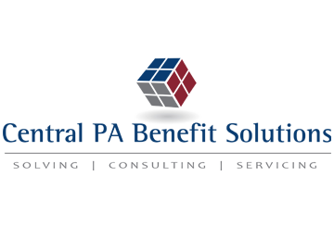
CMS Releases Cost-sharing Limits for 2024 Plan Years
Key Information
- The ACA requires health plans to place annual limits on enrollees’ out-of-pocket spending for EHB.
- This ACA requirement applies to all non-grandfathered health plans.
- CMS annually adjusts the ACA’s cost-sharing limits for inflation.
- CMS announced the cost-sharing limits for plan years beginning in 2024 on Dec. 12, 2022.
On Dec. 12, 2022, the Centers for Medicare and Medicaid Services (CMS) released the maximum limits on cost sharing for 2024 under the Affordable Care Act (ACA). For 2024, the maximum annual limitation on cost sharing is $9,450 for self-only coverage and $18,900 for family coverage. This represents an approximately 3.8% increase above the 2023 limits of $9,100 for self-only coverage and $18,200 for family coverage.
Out-of-Pocket Maximum
The ACA requires health plans to comply with annual limits on total enrollee cost sharing for essential health benefits (EHB). These cost-sharing limits are commonly referred to as an out-of-pocket maximum. CMS annually adjusts the ACA’s out-of-pocket maximum for inflation and publishes the limits by January of the year preceding the applicable benefit year. The ACA’s cost-sharing limits apply to all non-grandfathered health plans, including self-insured health plans and fully insured health plans of any size.
Any out-of-pocket expenses required by or on behalf of an enrollee with respect to EHB must count toward the cost-sharing limit. This includes deductibles, copayments, coinsurance and similar charges but excludes premiums and spending for noncovered services. Also, plans that use provider networks are not required to count an enrollee’s expenses for out-of-network benefits toward the cost-sharing limit.
Limits for 2023 and 2024
For plan years beginning in 2024, the out-of-pocket maximum is $9,450 for self-only coverage and $18,900 for family coverage. For plan years beginning in 2023, the limits are $9,100 and $18,200, respectively. Employers should review the plan designs each year to ensure they comply with the ACA’s cost-sharing limits.
For plan years beginning in 2024, the ACA’s cost-sharing limits for EHB are $9,450 for self-only coverage and $18,900 for family coverage.
Provided to you by Central PA Benefit Solutions

